Semaphore for Synchronization

- Race condition: A situation that several tasks access and manipulate the same data concurrently and the outcome of the execution depends on the particular order in which the access take place.

- Example:

– Suppose that the value of the variable counter = 5.

– Process 1 and process 2 execute the statements “counter++” and “counter--” concurrently.

– Following the execution of these two statements, the value of the variable counter may be 4, 5, or 6!

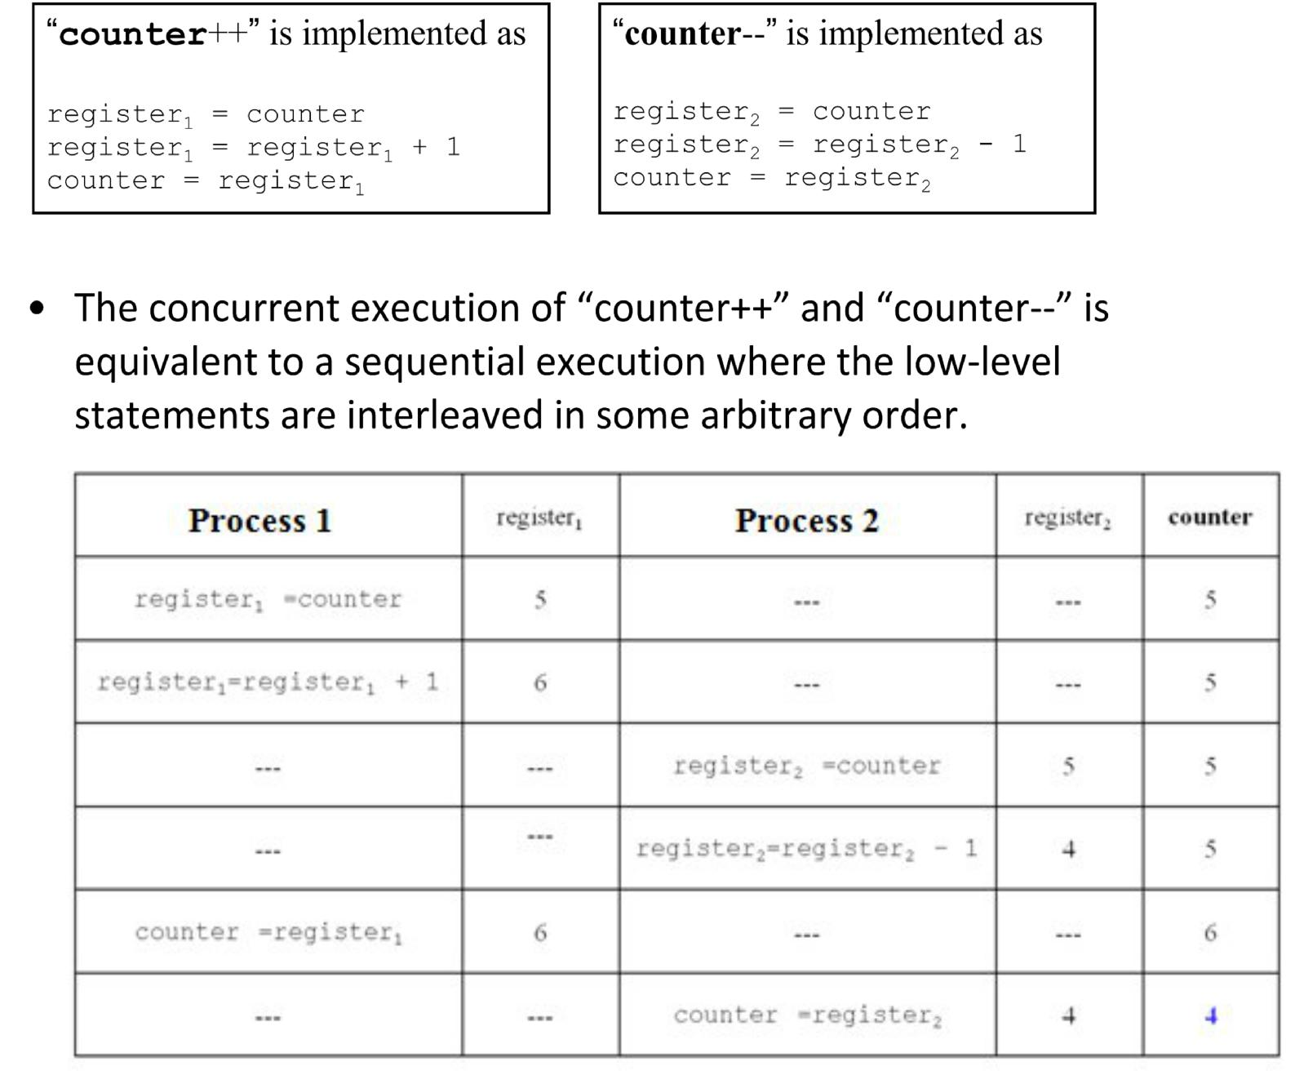

Shared memory synchronization

- There are two essential needs for synchronization between multiple processes executing on shared memory

– Establishing an order between two events

    - E.g. in the server and client case, we want to make sure the server finishes writing before the client reads

– Mutually exclusive access to a certain resource

    - Such as a data structure, a file, etc

    - E.g. Two people deposit to the same account

“deposit +=100”. We want to make sure that the increment happens one at a time. Why? (Let us look draw a time line showing possible interleaving of events)

- A semaphore can be used for both purposes

- An ordinary while loop (busy wait loop) is not safe for ensuring mutual exclusion

– Two processes may both think they have successfully set the lock and, so, have the exclusive access

    - Again, we can draw a time line showing possible interleaving of events that may lead to failed mutual exclusion

– A semaphore is guaranteed to be able to have the correct view of the locking status

The concept of semaphores

- Semaphores may be binary (0/1), or counting

- Every semaphore variable, s, It is initialized to
some positive value

- 1 for a binary semaphore

- N > 1 for a counting semaphore

Binary semaphores

- A binary semaphore , s , is used for mutual exclusion and wake up sync

1 == unlocked
0 == locked
- s, is associated with two operations:

- P(s)

– Tests s; if positive, resets s to 0 and proceed; otherwise, put the executing process to the back of a waiting queue for s

- V(s)

– Set s to 1 and wake up a process in the waiting queue for s

Counting semaphores

- A counting semaphore, s, is used for producer/consumer sync
n == the count of available resources
0 == no resource (locking consumers out)
- s, is associated with two operations:
- P(s)

– Tests s, if positive, decrements s and proceed

– otherwise, put the executing process to the back of a waiting queue for s

- V(s)

– Increments s; wakes up a process, if any, in the waiting queue for s

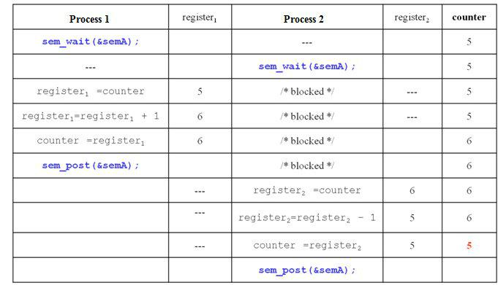

Critical Sections

- We like to think of locking a concurrent data structure

- In current practice, however, locks (incl. binary semaphores) are typically used to lock a segment of program statements (or instructions)

- Such a program segment is called a critical section

– A critical section is a program segment that may modify shared data structures

– It should be executed by one process at any given time

- With a binary semaphore

– If multiple processes are locked out of a critical section

    - As soon as the critical section is unlocked, only one process is allowed in

    - The other processes remain locked out

- Implementation of semaphores is fair to processes

    - A first‐come‐first‐serve queue

Unix Semaphores

- There are actually at least two implementations

- UNIX System V has an old implementation

– Analogous to shared memory system calls

– Calls to semget(), semat(), semctl(), etc

– Not as easy to use as POSIX implementation
- We will use POSIX implementation in

this course

POSIX semaphore system calls

- #include <semaphore.h>

- POSIX semaphores come in two forms: named semaphores and unnamed semaphores.

Using unnamed semaphores

- Unnamed semaphores are also called memory‐ based semaphores

– Named semaphores are “file‐based”

- An unnamed semaphore does not have a name.

– It is placed in a region of memory that is shared between multiple threads (a thread‐shared semaphore) or processes (a process‐shared semaphore).

- A process‐shared semaphore must be placed in a shared memory region

System calls

- Before being used, an unnamed semaphore must be initialized using sem_init(3). It can then be operated on using sem_post(3) and sem_wait(3).

- When the semaphore is no longer required, and before the memory in which it is located is deallocated, the semaphore should be destroyed using sem_destroy(3).

- Compile using ‐lrt

Recall that shared memory segments must be removed before program exits

- “An unnamed semaphore should be destroyed with sem_destroy() before the memory in which it is located is deallocated.”

- “ Failure to do this can result in resource leaks on some implementations.”

int sem_init(sem_t *sem, int pshared, unsigned int value);

- #include <semaphore.h>

- sem_init() initializes the unnamed semaphore at the address pointed to by sem. The value argument specifies the initial value for the semaphore.

- If pshared has the value 0, then the semaphore is shared between the threads of a process

- If pshared is nonzero, then the semaphore is shared between processes, and should be located in a region of shared memory

int sem_wait(sem_t *sem);

- sem_wait() decrements (locks) the semaphore pointed to by sem.

- If the semaphore's value is greater than zero, then the decrement proceeds, and the function returns, immediately.

- If the semaphore currently has the value zero, then the call blocks until either it becomes possible to perform the decrement (i.e., the semaphore value rises above zero), or a signal handler interrupts the call.

int sem_post(sem_t *sem);

- sem_post() increments (unlocks) the semaphore pointed to by sem.

- If the semaphore's value consequently becomes greater than zero, then another process or thread blocked in a sem_wait(3) call will be woken up

int sem_destroy(sem_t *sem);

- Destroys the unnamed semaphore at the address pointed to by sem. Only a semaphore that has been initialized by sem_init(3) should be destroyed using sem_destroy().

- Destroying a semaphore that other processes or threads are currently blocked on (in sem_wait(3)) produces undefined behavior.

- Using a semaphore that has been destroyed produces undefined results, until the semaphore has been reinitialized using sem_init(3).

Examples

- We first look at a bad example in which the unnamed semaphore is not placed in the shared memory (test1.c)

 |  |  | int shmid1;
 |  |  | int *shm1, *s;
// compile with ‐lrt |  |  | if ((shmid1 = shmget(IPC_PRIVATE,
#include <semaphore.h> |  |  | SHMSIZE, 0666)) < 0) {
 |  |  | perror("shmget");
#include <stdio.h>
 |  |  | exit(1);
#include <errno.h>
 |  |  | }
#include <stdlib.h>
 |  |  | if ((shm1 = shmat(shmid1, NULL, 0)) == (int
#include <unistd.h> |  |  | *) ‐1) {
#include <sys/types.h> |  |  | perror("shmat");
#include <sys/shm.h> |  |  | exit(1);
#include <sys/wait.h> |  |  | }
 |  |  | *shm1 = 0;
#define SHMSIZE 1024
 |  |  | ptr = shm1;
int main(int argc, char **argv)
{ | • | In this example, the semaphore is not
int i,nloop=10,*ptr;
sem_t mutex; |  | placed in the shared memory.
 | • | Therefore, it is ineffective for mutual
exclusion synchronization

/* create, initialize semaphore */
if( sem_init(&mutex,1,1) < 0)
{
perror("semaphore
initilization");
exit(0);
}

if (fork() == 0) { /* child process*/ sem_wait(&mutex);

for (i = 0; i < nloop; i++) { printf("child: %d\n", (*ptr)++); sleep(5);
}

sem_post(&mutex); exit(0);

}
/* back to parent process */ sem_wait(&mutex);

for (i = 0; i < nloop; i++) { printf("parent: %d\n",
(*ptr)++);
sleep(5);
}

sem_post(&mutex); wait(int *) 0); shmctl(shmid1, IPC_RMID, (struct shmid_ds *) 0); exit(0);

}

- The mutex is supposed to ensure that each process prints its entire data w/o mixing with the other process’ data
- But it fails to do so

- Next, we look at an even worse example:

– We want to let parent process prints its entire data first

– So we let child process wait for the process to give it a go‐ ahead

– Initialize the mutex variable to 0 and wait for the parent process to change it to 1.

- But we didn’t put the mutex variable in the shared memory

- The child process never wakes up!

- We need to manually kill the child process and free the shared memory

}

/* back to parent process */
for (i = 0; i < nloop; i++) printf("parent: %d\n", (*ptr)++);
sem_post(&mutex); exit(0);
#include ….. // stuck.c
int main(int argc, char **argv)
{
int i,nloop=10,*ptr;
sem_t mutex;
……

if( sem_init(&mutex,1,1) < 0) */
if( sem_init(&mutex,1,0) < 0) { …..
}
if (fork() == 0) { /* child process*/ sem_wait(&mutex);

for (i = 0; i < nloop; i++) printf("child: %d\n", (*ptr)++); exit(0)

}

- Finally, we will correct the errors by placing the semaphore in the shared memory

- We also need to remember to destroy the unnamed semaphore before removing the shared memory segment.

- Be careful with the timing for destroying the semaphore

– Make sure there should not be waiting processes

// nonstuck.c sem_t *p_mutex;
……
if ((shmid2 = shmget(IPC_PRIVATE, SHMSIZE, 0666)) < 0) { perror("shmget");
exit(1);
}
p_mutex = (sem_t *) shmat(shmid2, NULL, 0); if (p_mutex == (sem_t *) ‐1) {

perror("mutex shmat fails "); exit(1);
}
if( sem_init(p_mutex,1,0) < 0)
{
perror("semaphore initilization");
exit(1);
}
if (fork() == 0) { /* child process*/

sem_wait(p_mutex); // cont’d on next page

// nonstuck.c cont’d
if (fork() == 0) { /* child process*/ sem_wait(p_mutex);

for (i = 0; i < nloop; i++) printf("child: %d\n", (*ptr)++); sem_destroy(p_mutex);

shmctl(shmid2, IPC_RMID, (struct shmid_ds *) 0); shmctl(shmid1, IPC_RMID, (struct shmid_ds *) 0); exit(0);
}
/* back to parent process */ for (i = 0; i < nloop; i++) printf("parent: %d\n", (*ptr)++); sem_post(p_mutex);

exit(0);

- We can make a similar change to test1.c

- We will see that now each process will print its entire data without interleaving with other processes

- Which process writes first will be unknown in advance

